QUESTÃO A

(AvB)->(CvD)

|  |  |  |  |  |  |  |
| --- | --- | --- | --- | --- | --- | --- |
| TABELA VERDADE | | | | | | **QUESTÃO** |
| **A** | **B** | **C** | **D** | **(AvB)** | **(CvD)** | **(AvB)->(CvD)** |
| V | V | V | V | V | V | V |
| V | V | V | F | V | V | V |
| V | V | F | V | V | V | V |
| V | V | F | F | V | F | F |
| V | F | V | V | V | V | V |
| V | F | V | F | V | V | V |
| V | F | F | V | V | V | V |
| V | F | F | F | V | F | F |
| F | V | V | V | V | V | V |
| F | V | V | F | V | V | V |
| F | V | F | V | V | V | V |
| F | V | F | F | V | F | F |
| F | F | V | V | F | V | V |
| F | F | V | F | F | V | V |
| F | F | F | V | F | V | V |
| F | F | F | F | F | F | V |

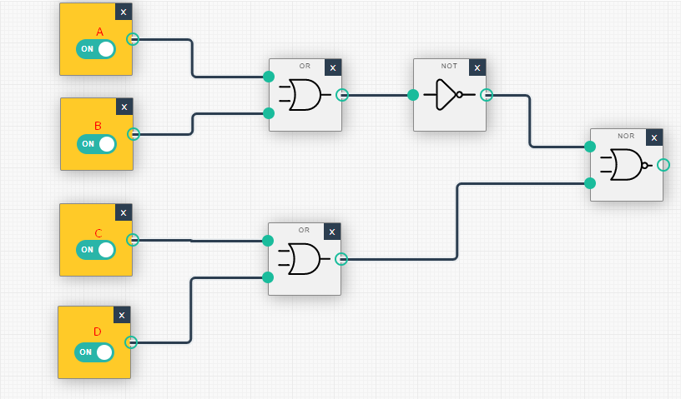

QUESTÃO B

(A^B)=>(CvD)

|  |  |  |  |  |  |  |
| --- | --- | --- | --- | --- | --- | --- |
| TABELA VERDADE | | | | | | **QUESTÃO** |
| **A** | **B** | **C** | **D** | **(A^B)** | **(CvD)** | **(AvB)=>(CvD)** |
| V | V | V | V | V | V | V |
| V | V | V | F | V | V | V |
| V | V | F | V | V | V | V |
| V | V | F | F | V | F | F |
| V | F | V | V | F | V | V |
| V | F | V | F | F | V | V |
| V | F | F | V | F | V | V |
| V | F | F | F | F | F | V |
| F | V | V | V | F | V | V |
| F | V | V | F | F | V | V |
| F | V | F | V | F | V | V |
| F | V | F | F | F | F | V |
| F | F | V | V | F | V | V |
| F | F | V | F | F | V | V |
| F | F | F | V | F | V | V |
| F | F | F | F | F | F | V |

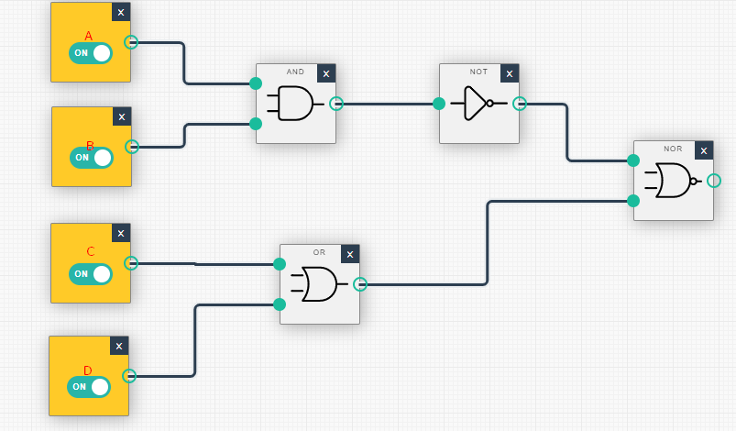

QUESTÃO C

(AvB)=>(C^D)

|  |  |  |  |  |  |  |
| --- | --- | --- | --- | --- | --- | --- |
| TABELA VERDADE | | | | | | **QUESTÃO** |
| **A** | **B** | **C** | **D** | **(AvB)** | **(C^D)** | **(AvB)=>(C^D)** |
| V | V | V | V | V | V | V |
| V | V | V | F | V | F | F |
| V | V | F | V | V | F | F |
| V | V | F | F | V | F | F |
| V | F | V | V | V | V | V |
| V | F | V | F | V | F | F |
| V | F | F | V | V | F | F |
| V | F | F | F | V | F | F |
| F | V | V | V | V | V | V |
| F | V | V | F | V | F | F |
| F | V | F | V | V | F | F |
| F | V | F | F | V | F | F |
| F | F | V | V | F | V | V |
| F | F | V | F | F | F | V |
| F | F | F | V | F | F | V |
| F | F | F | F | F | F | V |

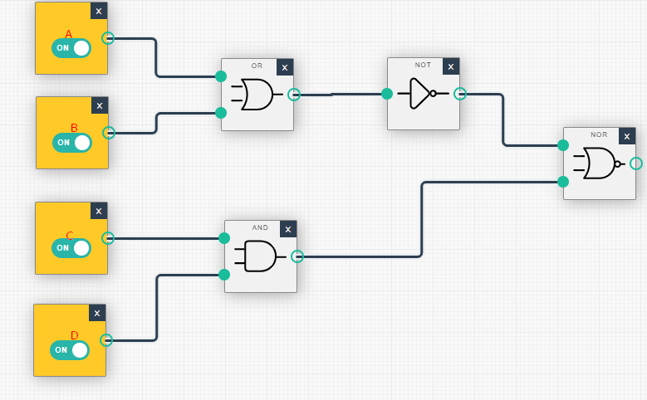

QUESTÃO D

(A^B)=>(C^D)

|  |  |  |  |  |  |  |
| --- | --- | --- | --- | --- | --- | --- |
| TABELA VERDADE | | | | | | **QUESTÃO** |
| **A** | **B** | **C** | **D** | **(A^B)** | **(C^D)** | **(A^B)=>(C^D)** |
| V | V | V | V | V | V | V |
| V | V | V | F | V | F | F |
| V | V | F | V | V | F | F |
| V | V | F | F | V | F | F |
| V | F | V | V | F | V | V |
| V | F | V | F | F | F | V |
| V | F | F | V | F | F | V |
| V | F | F | F | F | F | V |
| F | V | V | V | F | V | V |
| F | V | V | F | F | F | V |
| F | V | F | V | F | F | V |
| F | V | F | F | F | F | V |
| F | F | V | V | F | V | V |
| F | F | V | F | F | F | V |
| F | F | F | V | F | F | V |
| F | F | F | F | F | F | V |

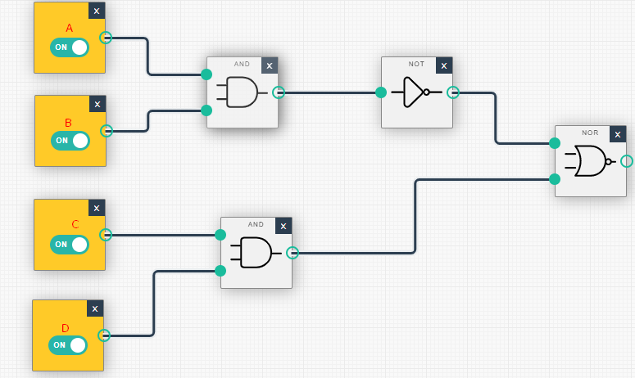

QUESTÃO E

(~AvB)=>(CvD)

|  |  |  |  |  |  |  |  |
| --- | --- | --- | --- | --- | --- | --- | --- |
|  | TABELA VERDADE | | | | | | **QUESTÃO** |
| **A** | **~A** | **B** | **C** | **D** | **(~AvB)** | **(CvD)** | **(~AvB)=>(CvD)** |
| V | F | V | V | V | V | V | V |
| V | F | V | V | F | V | V | V |
| V | F | V | F | V | V | V | V |
| V | F | V | F | F | V | F | F |
| V | F | F | V | V | F | V | V |
| V | F | F | V | F | F | V | V |
| V | F | F | F | V | F | V | V |
| V | F | F | F | F | F | F | V |
| F | V | V | V | V | V | V | V |
| F | V | V | V | F | V | V | V |
| F | V | V | F | V | V | V | V |
| F | V | V | F | F | V | F | F |
| F | V | F | V | V | V | V | V |
| F | V | F | V | F | V | V | V |
| F | V | F | F | V | V | V | V |
| F | V | F | F | F | V | F | F |

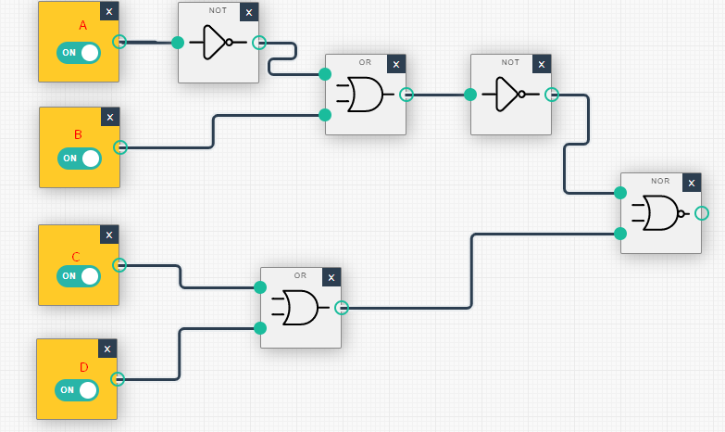

QUESTÃO F

(A^B)=>(~CvD)

|  |  |  |  |  |  |  |  |
| --- | --- | --- | --- | --- | --- | --- | --- |
|  | TABELA VERDADE | | | | | | **QUESTÃO** |
| **A** | **B** | **C** | **~C** | **D** | **(A^B)** | **(~CvD)** | **(A^B)=>(~CvD)** |
| V | V | V | F | V | V | V | V |
| V | V | V | F | F | V | F | F |
| V | V | F | V | V | V | V | V |
| V | V | F | V | F | V | V | V |
| V | F | V | F | V | F | V | V |
| V | F | V | F | F | F | V | V |
| V | F | F | V | V | F | V | V |
| V | F | F | V | F | F | V | V |
| F | V | V | F | V | F | V | V |
| F | V | V | F | F | F | F | V |
| F | V | F | V | V | F | V | V |
| F | V | F | V | F | F | V | V |
| F | F | V | F | V | F | V | V |
| F | F | V | F | F | F | V | V |
| F | F | F | V | V | F | V | V |
| F | F | F | V | F | F | V | V |

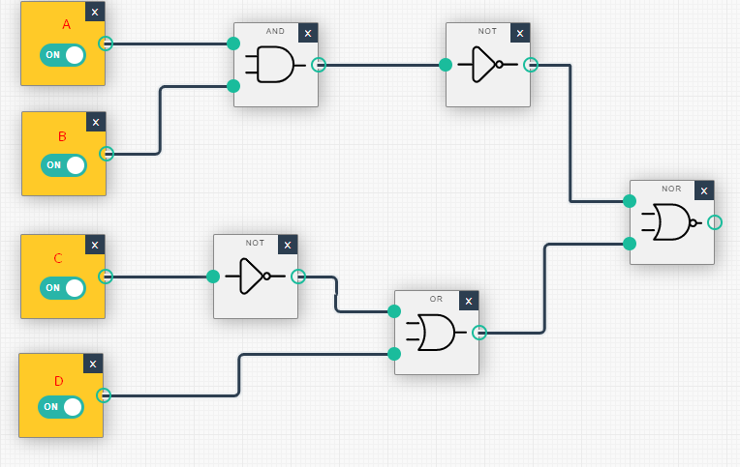

QUESTÃO G

(AvB)=>(~C^~D)

|  |  |  |  |  |  |  |  |  |  |  |
| --- | --- | --- | --- | --- | --- | --- | --- | --- | --- | --- |
|  |  | | TABELA VERDADE | | | | | | | **QUESTÃO** |
| **A** | | **B** | | **C** | **D** | **~C** | **~D** | **(AvB)** | **(~C^~D)** | **(AvB)=>(~C^~D)** |
| V | | V | | V | V | F | F | V | F | F |
| V | | V | | V | F | F | V | V | F | F |
| V | | V | | F | V | V | F | V | F | F |
| V | | V | | F | F | V | V | V | V | V |
| V | | F | | V | V | F | F | V | F | F |
| V | | F | | V | F | F | V | V | F | F |
| V | | F | | F | V | V | F | V | F | F |
| V | | F | | F | F | V | V | V | V | V |
| F | | V | | V | V | F | F | V | F | F |
| F | | V | | V | F | F | V | V | F | F |
| F | | V | | F | V | V | F | V | F | F |
| F | | V | | F | F | V | V | V | V | V |
| F | | F | | V | V | F | F | F | F | V |
| F | | F | | V | F | F | V | F | F | V |
| F | | F | | F | V | V | F | F | F | V |
| F | | F | | F | F | V | V | F | V | V |

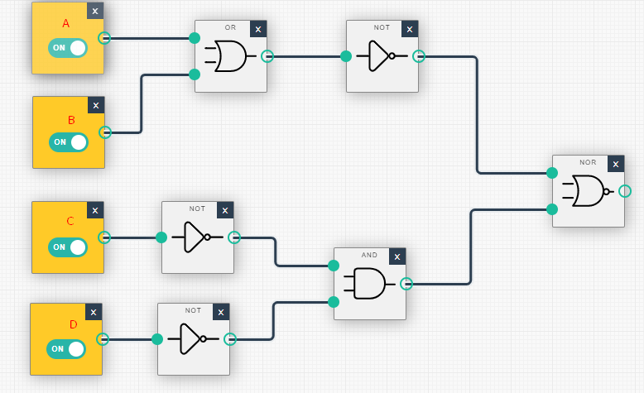

QUESTÃO H

(~A^~B)=>(~C^~D)

|  |  |  |  |  |  |  |  |  |  |  |  |  |  |
| --- | --- | --- | --- | --- | --- | --- | --- | --- | --- | --- | --- | --- | --- |
|  |  | |  | |  | | TABELA VERDADE | | | | | | **QUESTÃO** |
| **A** | | **B** | | **C** | | **D** | **~A** | **~B** | **~C** | **~D** | **(~A^~B)** | **(~C^~D)** | **(~A^~B)=>(~C^~D)** |
| V | | V | | V | | V | F | F | F | F | F | F | V |
| V | | V | | V | | F | F | F | F | V | F | F | V |
| V | | V | | F | | V | F | F | V | F | F | F | V |
| V | | V | | F | | F | F | F | V | V | F | V | V |
| V | | F | | V | | V | F | V | F | F | F | F | V |
| V | | F | | V | | F | F | V | F | V | F | F | V |
| V | | F | | F | | V | F | V | V | F | F | F | V |
| V | | F | | F | | F | F | V | V | V | F | V | V |
| F | | V | | V | | V | V | F | F | F | F | F | V |
| F | | V | | V | | F | V | F | F | V | F | F | V |
| F | | V | | F | | V | V | F | V | F | F | F | V |
| F | | V | | F | | F | V | F | V | V | F | V | V |
| F | | F | | V | | V | V | V | F | F | V | F | F |
| F | | F | | V | | F | V | V | F | V | V | F | F |
| F | | F | | F | | V | V | V | V | F | V | F | F |
| F | | F | | F | | F | V | V | V | V | F | V | V |

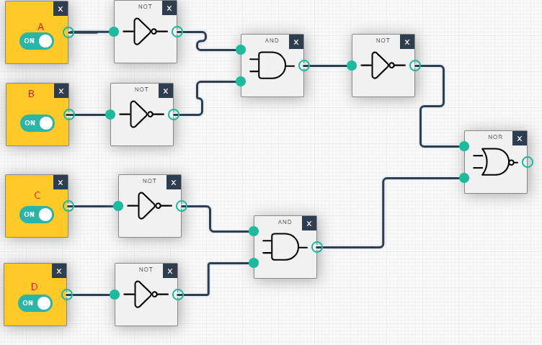

QUESTÃO I

(A=>B)v(CvD)

|  |  |  |  |  |  |  |
| --- | --- | --- | --- | --- | --- | --- |
| TABELA VERDADE | | | | | | **QUESTÃO** |
| **A** | **B** | **C** | **D** | **(A=>B)** | **(CvD)** | **(A=>B)v(CvD)** |
| V | V | V | V | V | V | V |
| V | V | V | F | V | V | V |
| V | V | F | V | V | V | V |
| V | V | F | F | V | F | V |
| V | F | V | V | F | V | V |
| V | F | V | F | F | V | V |
| V | F | F | V | F | V | V |
| V | F | F | F | F | F | F |
| F | V | V | V | V | V | V |
| F | V | V | F | V | V | V |
| F | V | F | V | V | V | V |
| F | V | F | F | V | F | V |
| F | F | V | V | V | V | V |
| F | F | V | F | V | V | V |
| F | F | F | V | V | V | V |
| F | F | F | F | V | F | V |

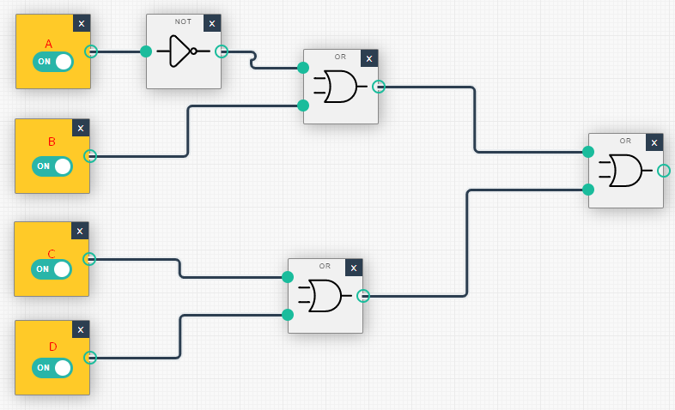

QUESTÃO J

|  |  |  |  |  |  |  |
| --- | --- | --- | --- | --- | --- | --- |
|  | TABELA VERDADE | | | | | **QUESTÃO** |
| **A** | **B** | **C** | **D** | **(A^B)** | **(C=>D)** | **(A^B)^(C=>D)** |
| V | V | V | V | V | V | V |
| V | V | V | F | V | F | F |
| V | V | F | V | V | V | V |
| V | V | F | F | V | V | V |
| V | F | V | V | F | V | F |
| V | F | V | F | F | F | F |
| V | F | F | V | F | V | F |
| V | F | F | F | F | V | F |
| F | V | V | V | F | V | F |
| F | V | V | F | F | F | F |
| F | V | F | V | F | V | F |
| F | V | F | F | F | V | F |
| F | F | V | V | F | V | F |
| F | F | V | F | F | F | F |
| F | F | F | V | F | V | F |
| F | F | F | F | F | V | F |

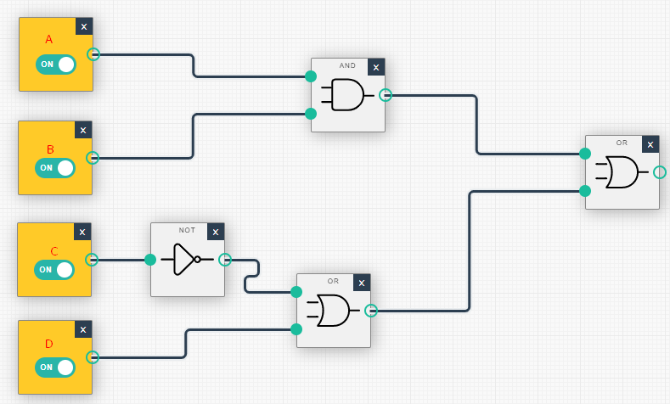

QUESTÃO K

(A=>B)^(C=>D)

|  |  |  |  |  |  |  |
| --- | --- | --- | --- | --- | --- | --- |
|  | TABELA VERDADE | | | | | **QUESTÃO** |
| **A** | **B** | **C** | **D** | **(A=>B)** | **(C=>D)** | **(A=>B)^(C=>D)** |
| V | V | V | V | V | V | V |
| V | V | V | F | V | F | F |
| V | V | F | V | V | V | V |
| V | V | F | F | V | V | V |
| V | F | V | V | F | V | F |
| V | F | V | F | F | F | F |
| V | F | F | V | F | V | F |
| V | F | F | F | F | V | F |
| F | V | V | V | V | V | V |
| F | V | V | F | V | F | F |
| F | V | F | V | V | V | V |
| F | V | F | F | V | V | V |
| F | F | V | V | V | V | V |
| F | F | V | F | V | F | F |
| F | F | F | V | V | V | V |
| F | F | F | F | V | V | V |

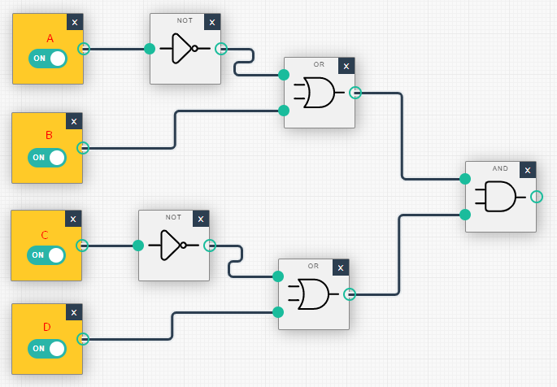

QUESTÃO L

(A=>B)v(C=>D)

|  |  |  |  |  |  |  |
| --- | --- | --- | --- | --- | --- | --- |
|  | TABELA VERDADE | | | | | **QUESTÃO** |
| **A** | **B** | **C** | **D** | **(A=>B)** | **(C=>D)** | **(A=>B)v(C=>D)** |
| V | V | V | V | V | V | V |
| V | V | V | F | V | F | V |
| V | V | F | V | V | V | V |
| V | V | F | F | V | V | V |
| V | F | V | V | F | V | V |
| V | F | V | F | F | F | F |
| V | F | F | V | F | V | V |
| V | F | F | F | F | V | V |
| F | V | V | V | V | V | V |
| F | V | V | F | V | F | V |
| F | V | F | V | V | V | V |
| F | V | F | F | V | V | V |
| F | F | V | V | V | V | V |
| F | F | V | F | V | F | V |
| F | F | F | V | V | V | V |
| F | F | F | F | V | V | V |

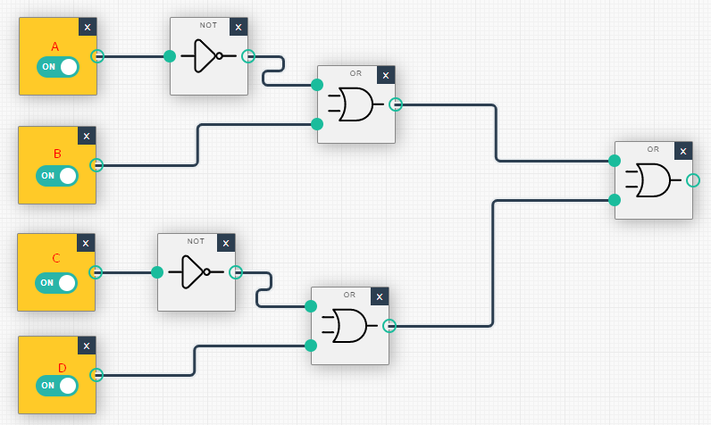

QUESTÃO M

(~A=>B)v(C=>D)

|  |  |  |  |  |  |  |  |
| --- | --- | --- | --- | --- | --- | --- | --- |
|  | TABELA VERDADE | | | | | | **QUESTÃO** |
| **A** | **~A** | **B** | **C** | **D** | **(~A=>B)** | **(C=>D)** | **(~A=>B)v(C=>D)** |
| V | F | V | V | V | V | V | V |
| V | F | V | V | F | V | F | V |
| V | F | V | F | V | V | V | V |
| V | F | V | F | F | V | V | V |
| V | F | F | V | V | V | V | V |
| V | F | F | V | F | V | F | V |
| V | F | F | F | V | V | V | V |
| V | F | F | F | F | V | V | V |
| F | V | V | V | V | V | V | V |
| F | V | V | V | F | V | F | V |
| F | V | V | F | V | V | V | V |
| F | V | V | F | F | V | V | V |
| F | V | F | V | V | F | V | V |
| F | V | F | V | F | F | F | F |
| F | V | F | F | V | F | V | V |
| F | V | F | F | F | F | V | V |

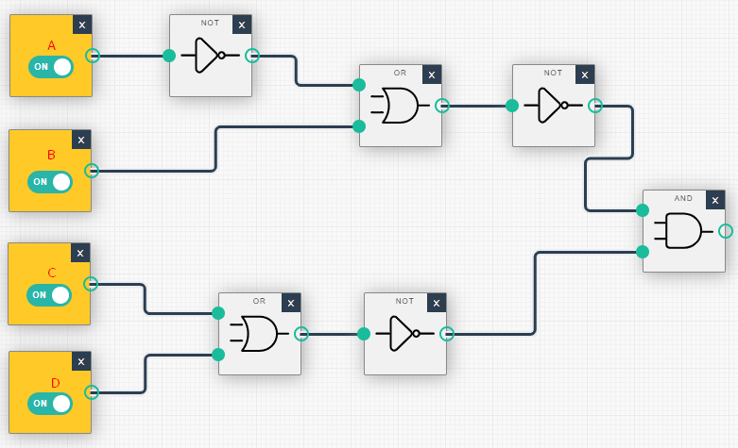

QUESTÃO N

(A=>B)v(~CvD)

|  |  |  |  |  |  |  |  |
| --- | --- | --- | --- | --- | --- | --- | --- |
|  | TABELA VERDADE | | | | | | **QUESTÃO** |
| **A** | **B** | **C** | **~C** | **D** | **(A=>B)** | **(~CvD)** | **(A=>B)v(~CvD)** |
| V | V | V | F | V | V | V | V |
| V | V | V | F | F | V | V | V |
| V | V | F | V | V | V | V | V |
| V | V | F | V | F | V | F | V |
| V | F | V | F | V | F | V | V |
| V | F | V | F | F | F | V | V |
| V | F | F | V | V | F | V | V |
| V | F | F | V | F | F | F | F |
| F | V | V | F | V | V | V | V |
| F | V | V | F | F | V | V | V |
| F | V | F | V | V | V | V | V |
| F | V | F | V | F | V | F | V |
| F | F | V | F | V | V | V | V |
| F | F | V | F | F | V | V | V |
| F | F | F | V | V | V | V | V |
| F | F | F | V | F | V | F | V |

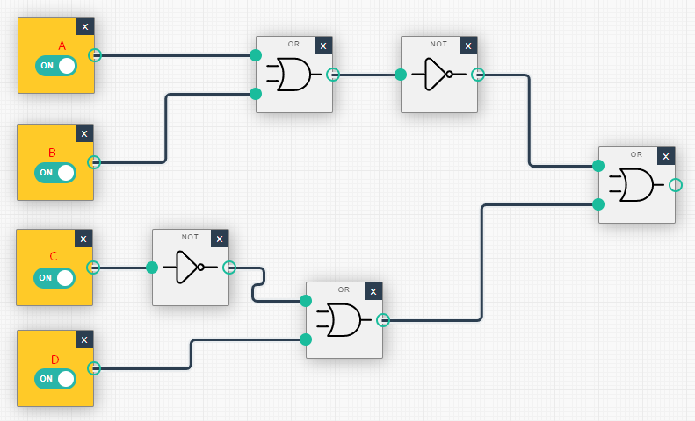

QUESTÃO O

(A=>B)=>(~C^~D)

|  |  |  |  |  |  |  |  |  |  |  |
| --- | --- | --- | --- | --- | --- | --- | --- | --- | --- | --- |
|  |  | | TABELA VERDADE | | | | | | | **QUESTÃO** |
| **A** | | **B** | | **C** | **D** | **~C** | **~D** | **(A=>B)** | **(~C^~D)** | **(A=>B)=>(~C^~D)** |
| V | | V | | V | V | F | F | V | F | F |
| V | | V | | V | F | F | V | V | F | F |
| V | | V | | F | V | V | F | V | F | F |
| V | | V | | F | F | V | V | V | V | V |
| V | | F | | V | V | F | F | F | F | V |
| V | | F | | V | F | F | V | F | F | V |
| V | | F | | F | V | V | F | F | F | V |
| V | | F | | F | F | V | V | F | V | V |
| F | | V | | V | V | F | F | V | F | F |
| F | | V | | V | F | F | V | V | F | F |
| F | | V | | F | V | V | F | V | F | F |
| F | | V | | F | F | V | V | V | V | V |
| F | | F | | V | V | F | F | V | F | F |
| F | | F | | V | F | F | V | V | F | F |
| F | | F | | F | V | V | F | V | F | F |
| F | | F | | F | F | V | V | V | V | V |

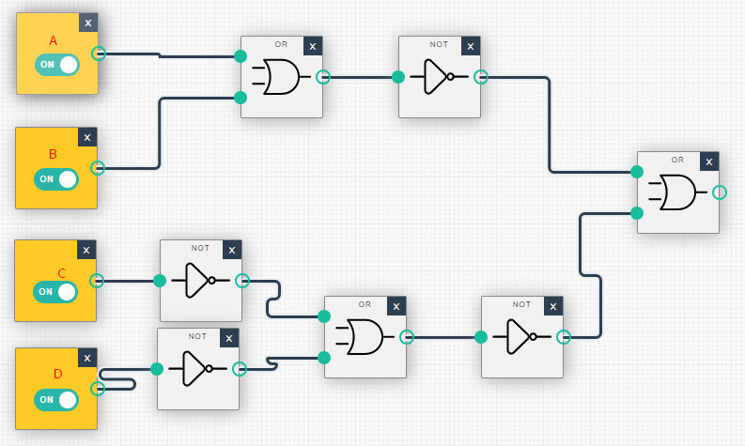

QUESTÃO P

(~A=>~B)=>(~C=>D)

|  |  |  |  |  |  |  |  |  |  |  |  |  |  |
| --- | --- | --- | --- | --- | --- | --- | --- | --- | --- | --- | --- | --- | --- |
|  |  | |  | |  | |  | | TABELA VERDADE | | | | **QUESTÃO** |
| **A** | | **B** | | **C** | | **~C** | | **D** | **~A** | **~B** | **(~A=>~B)** | **(~C=>D)** | **(~A=>~B)=>(~C=>D)** |
| V | | V | | V | | F | | V | F | F | V | V | V |
| V | | V | | V | | F | | F | F | F | V | V | V |
| V | | V | | F | | V | | V | F | F | V | V | V |
| V | | V | | F | | V | | F | F | F | V | F | F |
| V | | F | | V | | F | | V | F | V | V | V | V |
| V | | F | | V | | F | | F | F | V | V | V | V |
| V | | F | | F | | V | | V | F | V | V | V | V |
| V | | F | | F | | V | | F | F | V | V | F | F |
| F | | V | | V | | F | | V | V | F | F | V | V |
| F | | V | | V | | F | | F | V | F | F | V | V |
| F | | V | | F | | V | | V | V | F | F | V | V |
| F | | V | | F | | V | | F | V | F | F | F | V |
| F | | F | | V | | F | | V | V | V | V | V | V |
| F | | F | | V | | F | | F | V | V | V | V | V |
| F | | F | | F | | V | | V | V | V | V | V | V |
| F | | F | | F | | V | | F | V | V | V | F | F |

